**Quarterly Narrative Report (QNR)**

# **1. Project Details**

GUIDELINES: Please complete the following table with details of the project.

|  |  |
| --- | --- |
| Project Number | P 3589 |
| Project Title | BCH/CBM Ear, Nose and Throat (ENT) Project |
| City/ Country/ Region | Lusaka/Zambia/Southern Africa |
|  |  |
| Name of Contractual Partner | Beit Cure Hospital |
| Other Implementing Partners |  |
|  |  |
| Duration of Project | 3 Years |
| Project Start Date | January, 2018 |
| Project End Date | December, 2020 |
| Project Cycle | January-December |
|  |  |
| Report Submitted by; |  |
| Name | Stephen Chishimba |
| Designation | Project Manager |
| Email Address | steve.chishimba@cureinternational.org |
|  |  |
| Reporting Period (Q1, Q2…) | Q2, 2020 |
| Date of Submission | 10th July 2020. |

# **2. Summary of Results Achievements**

GUIDELINES: Insert a qualitative ‘summary’ of the overall progress of the project towards its Result areas. Please focus on the changes (intentional or unintentional) that have come about as a result of implementation of activities. Limit your response to 1 paragraph per result area.

**Result Area 1:** During the period under review the hospital significantly reduced on the overall number of patients being screened (25-35 patients per day for ENT) within the month of April and May in line with public health guidelines to avoid overcrowding. As a result, we observed a decline in the total number of patients seen for the 2 months mentioned.

The BCH ENT Clinic was able to screen a total of 866 patients, comprised of males (93), females (142), boys (325) and girls (306) with different ear conditions.

As a hospital we have conducted more minor surgeries as opposed to major surgeries based on the diagnosis provided and condition of the patients thereof reducing the chances of infections, risk on a patient’s life and increasing the recovery time for patients. This has also contributed to an increased success rate with the surgeries being conducted.

During the period under review we resumed our speech therapy services with the month of June being the only month services were provided. During this quarter we have 68% of the patients assessed as new patients which was progressive as it provides us with some re-assurance on the demand that the services is generating.

**Expenditure summary** Below is the expenditure summary for the period under review and stated per activity.

* Please note that the amount spent under the mobile outreaches was for sensitization and communication to health centers on cancellation of scheduled outreaches clinics. In addition, K6,227.50 was spent on consumables in preparation for the resumption of clinics.
* A total of K9,000 was spent on activity 01.05 Speech Therapy between May and June on account of the Hospital as funds available in the project account was not adequate to meet the cost.

|  |  |  |
| --- | --- | --- |
| **Description** | **Activity** | **Amount**  **ZMW** |
| Expenditure on ENT Consultations | 01.01 | 99,605.98 |
| Expenditure on Surgery related costs | 01.02 | 411,028.98 |
| Cost of ENT Mobile Outreaches within Lusaka | 01.03 | 11,947.50 |
| Expenditure on provision of Audiological services | 01.04 | 15,719.14 |
| Expenditure on Speech Therapy services | 01.05 | 0.00 |
| Support to the National ENT Committee | 02.01 | 0.00 |
| Project Management support | 03.01 | 28,811.16 |
| Support towards untility bills and other expenses | 03.02 | 40,665.80 |
| Project vehicle related costs | 03.03 | 13,141.09 |
| Audit of Financial Statement | 03.04 | 25,520.00 |
| **Total Expenditure for the quarter** | | **K646,439.65** |

**Result area 3:** Provide operational management and financial sustainability in ENT Clinic.

During the quarter an External auditing firm, Client Focus Solution Chartered Accountants Zambia was engaged to carry out an audit of the project, which was completed and cost K25,520.

# **3. Narrative Reporting on Activity Implementation**

3.1 GUIDELINES: Which activities were planned to be implemented for the quarter? Please list down the Activity Name and Number only.

**Result Area 1: ENT and rehabilitation services**

* 3.1 Activity 01.01 Conduct ENT consultations
* 3.2 Activity 01.02 Conduct ENT surgeries (25% of children's surgeries subsidized by CBM)
* 3.4 Activity 01.04 Conduct Audiology Consultations
* 3.5 Activity 01.05 Provide speech therapy sessions for children

**Result Area 3: Provide operational management and financial sustainability in ENT Clinic.**

* Facilitate annual certified audit and respond to outstanding audit issues

The financial audit for the year 2019 was done and concluded in May, 2020.

3.2 GUIDELINES: Using the list above, please report on the activities implemented during the quarter. Describe if any targets were achieved or explain any variance in achieved versus planned activities in the quarter. Explain who the main beneficiaries were.

**Result Area 1:ENT (diagnostic and surgery) and rehabilitative services (audiology and audio-verbal therapy) provided to a larger number of patients**

Below is a table that shows the overall progress made under each activity area within the result area.

***Table 1: Semi-Annual Performance for Result Area 1***

|  |  |  |  |  |  |  |  |  |  |
| --- | --- | --- | --- | --- | --- | --- | --- | --- | --- |
| Activity Area | Target | Q 1 Achieved | % Progress | Target | Q 2 Achieved | % Progress | Cumuli. Target | Cumul. Progress | Cumul. % Progress |
| **ENT Consultations/BCH Clinic** | 1175 | 2,201 | **187** | 1175 | 866 | **74** | 2350 | 3,067 | **131** |
| **ENT Surgeries** | 90 | 150 | **167** | 90 | 109 | **121** | 180 | 259 | **144** |
| **Outreach Clinics & School Screening** | 1950 | 2600 | **133** | 1950 | 0 | **0** | 3900 | 2,600 | **67** |
| **Audiology Consultations** | 1000 | 1071 | **107** | 1000 | 415 | **42** | 2000 | 1486 | **74** |
| **Speech Therapy Sessions** | 102 | 88 | **86** | 102 | 22 | **22** | 204 | 110 | **54** |

**Activity 01.01: Conduct ENT Consultations**

The ENT clinic observed a decline in the total number of patients seen in April and May. The public health guidelines have however started been relaxed for the country to accommodate and adjust to the new way of living ensuring that adequate personal protection and public health measures be put in place. As a hospital we have however been able to supersede our overall target up to this point in time on overall consultations conducted at 131% progress cumulatively. With COVID 19 restrictions slowly been eased with Beit CURE being guided by the Public Health Office for our geographical region we are poised to increase the total number of patients that we shall be screening in a day. The graph below provides and overview of the impact that the COVID 19 has had on the overall patient turnout at Beit CURE for ENT out-patient services.

***Graph 1: ENT OPD trends during 2020.***

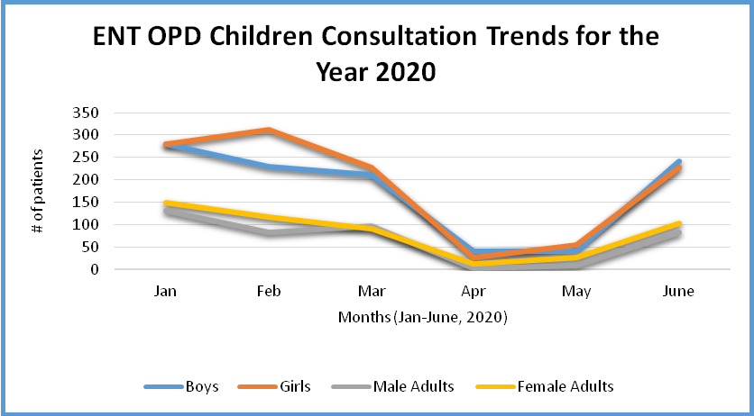

**Activity 01: 02 Conduct ENT Surgeries**

During the period under review, the hospital successfully undertook 109 surgeries of which 89 were minor whilst 20 of them were major surgeries. The number was segregated as: boys (62), girls (43), male (1) and females (3). The types of surgery procedures ranged from adenotosillectomy (throat), right tympanoplasty (ear) and turbinectomy (nose). The surgeries were successful and the 105 children would be able to engage in various in their communities such as attending school and other social activities, by reducing hearing loss. The achievement was attributed to the right interventions by the surgeons and the post operation care provided in the children’s ward. With reference made from table 1 the cumulative progress made under this activity is at 144% despite the current pandemic. During the months (April and May) when we had a lower patient inflow we focused on re-scheduling most of the surgeries that had been scheduled for later dates (post quarter 2) to be undertaken sooner and during this quarter and also allow for an evenly spread surgery schedule so as not to over-crowd our In-Patient Department (Children’s Ward).

As a hospital we have conducted more minor surgeries as opposed to major surgeries based on the diagnosis provided and condition of the patients thereof reducing the chances of infections, risk on a patient’s life and increasing the recovery time for patients. This has also contributed to an increased success rate with the surgeries being conducted. The graph below shows the composition of the types of surgeries conducted and the number of patients operated on.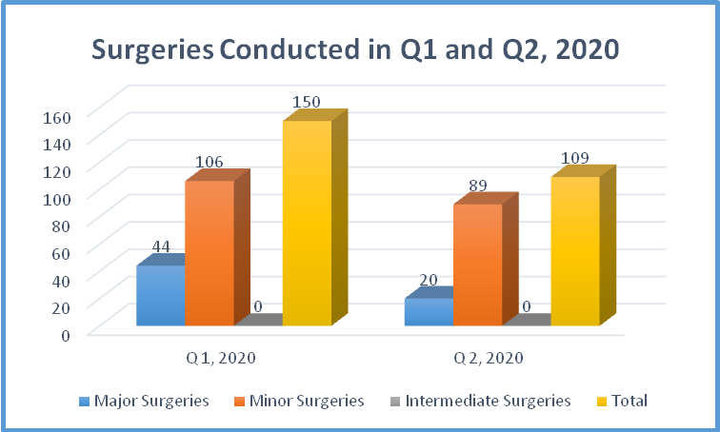

***Graph 2 Above: Surgeries conducted between Jan-June 2020.***

**Surgeries Conducted disaggregated by Sex.**

The graph (on the left) shows that during the first (1) quarter we conducted more surgeries on girls than boys as opposed to quarter two (2) in which we observed a slight increase in surgeries conducted to boys than girls. The hospital has not yet conducted any intermediate surgery (low risk surgical procedure undertaken during the day).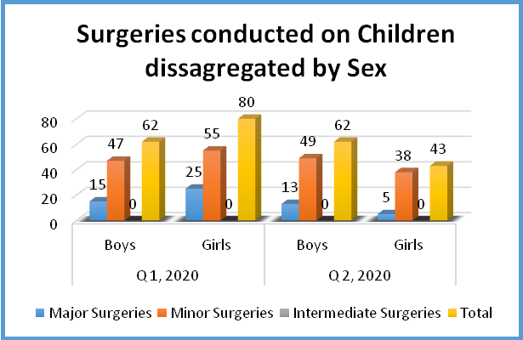

**Activity 01.04 Conduct Audiology Consultations**

The cumulative progress made under Audiological consultations this year is currently at 1486 (74%) which continues to be below the target taking into consideration the global health pandemic that has contributed to a reduced turnover of patients at the hospital. As a hospital we do hold hope that the turnover will increase as we have gradually been increasing the total number of patients being screened at the ENT Out-Patient Department.

|  |  |  |  |
| --- | --- | --- | --- |
| **Audiology Consultation Assessment** | **Q 1 2020** | **Q 2 2020** | **Patients Screened** |
| **Audiograms** | 255 | 92 | 347 |
| **Tympanograms** | 431 | 153 | 584 |
| **OAES** | 119 | 43 | 162 |
| **Hearing Aids Dispended** | 55 | 26 | 81 |
| **Infant Screening** | 1 | 0 | 1 |
| **TINNITUS** | 1 | 1 | 2 |
| **ABRs / ASSRs** | 19 | 10 | 29 |
| **VRA** | 0 | 0 | 0 |
| **Other Proc** | 5 | 15 | 20 |
| **Walk in Patients** | 2 | 4 | 6 |
| **Hearing Aid follow up** | 90 | 37 | 127 |
| **Ear Molds** | 93 | 34 | 127 |
| **Total Screenings Conducted** | **1071** | **415** | **1486** |

The cumulative results show that more tympanogram tests were conducted more than audiograms and OAE’s. More tympanogram tests conducted during the course of the year translates to a higher number of patients being diagnosed by the ENT specialist with the suspicion that those patients have problems found within middle ear and specifically the ear drum responsible for transmission of sound. The audiogram tests were the second highest provided during the year which translates to suspicion of disabling hearing loss amongst the patients being screened. OAE’s have been the third highest tests conducted (tests conducted to children under anesthesia for audiogram testing for children that cannot be conditioned to respond in an ordinary audiogram test).

The table below shows the gender split for the 02 quarters

|  |  |  |  |
| --- | --- | --- | --- |
| Gender | Quarter 01 | Quarter 02 | Total |
| Male | 289 | 92 | 381 |
| Female | 230 | 84 | 314 |
| Boy | 297 | 121 | 418 |
| Girl | 255 | 118 | 373 |
| Total | 1,071 | 415 | 1,486 |

**Activity 01.05 Provide speech therapy sessions for children**

# During the period under review we resumed our speech therapy services with the month of June being the only month services were provided.. BCH has thoroughly been observing precaution on the process and public health guideline to ensure both the caregiver of the patient are well equipped with masks and sanitizer as the therapy is being provided. The table below shows the progress made during Q 2, 2020. With an increased number of patients, we hope to slowly increase the number of patients being seen by the speech therapist technician as the numbers of patients at the ENT Out-patient department gradually increases.

***Table 2: Speech Therapy Summary during Q 2, 2020.***

|  |  |  |  |
| --- | --- | --- | --- |
| **Speech Therapy Progress made during the quarter** | Children | | |
| **Boys** | **Girls** | **Total** |
| Total Assessed during the Quarter | **17** | **5** | **22** |
| Total New Assessments Referred from BCH Audiology | 13 | 2 | 15 |
| Attending Routine Therapy | 11 | 4 | 15 |
| Home Programme Assessment | 1 | 1 | 2 |
| Discharged due to Improvements | 1 | 0 | 1 |
| First Time Assessed/But No Therapy | 4 | 1 | 5 |
| Total Assessed and fitted with Hearing Aids | 0 | 0 | 0 |

# We currently are at 22% progress for this quarter and cumulatively at 54%. We hope to make progress in quarter 3 as we gradually increase on the OPD patient inflow. During this quarter we have 68% of the patients assessed as new patients which was progressive as it provides us with some re-assurance on the demand that the services is generating. Of the 15 new patients assessed 5 of those patients were assessed without providing any therapy services because the child needed further investigations/assessments to be made by a Neuro-pediatrician because they showed symptoms of Autism Spectrum Disorder.

# ***Table 3: Children assessed disaggregated by age range during Q 2, 2020.***

|  |  |  |  |
| --- | --- | --- | --- |
| **Children Assessed by Age Range** | **Boys** | **Girls** | **Total** |
| Less than 5 years of Age | 11 | 3 | 14 |
| Between 5 years - 17 years of Age | 7 | 1 | 8 |
| 18 years and above | 0 | 0 | 0 |
|  |  |  |  |
| **TOTAL** | **18** | **4** | **22** |

From the table above we observe that 14 patients seen this quarter were less than 5 years whilst the remaining 8 children were aged between 5-17 years of age and this is mainly due to the fact children are typically identified at a much younger age when found with speech disorder.. This also provides us with hope that parents are becoming more aware on the need to take their children for Ear and Hearing screening to identify children with disabling hearing loss and avoid delayed speech or speech disorders.

# **4. Challenges and Lessons Learned**

GUIDELINES: Please complete the table below with challenges that were encountered during the reporting period and the lessons learned. Include any solution that you plan to implement in the next reporting period. (If you have used the Status Column in the Indicator Tracking Sheet (Column K) to report Challenges against specific indicators, make sure you elaborate on the challenge in the table below)

|  |  |
| --- | --- |
| **Challenge** | **Lessons learned / solutions** |
| Global Pandemic (COVID 19) virus. | * The pandemic can affect everyone without an exception; hence the BCH is applying the Ministry of Health corona guidelines in all its operations. * BCH continues to consult a gradual number of (35) patients since it resumed operations after the government relaxing the restrictions |

# **5. Changes in Implementation Plan and Personnel (if applicable)**

GUIDELINES: Please use the space below to specify any changes to (I) the implementation plan (strategies, timelines, targets or key results; also specify if any approval for changes has been sought from CBM), (II) any changes in personnel at the organization’s senior management level, (III) key positions related to the project implementation.

**Change 1:Beit Cure Hospital Zambia has a new Executive Director who commences in August 2020.**

After successfully conducting a recruitment search, CURE International successfully recruited Fridah Phiri, a Zambian woman who was previously based in Lesotho working as a Country Director for a Non-Governmental Organization. Full details of her resume’ and background shall be provided as soon as she settles in her new role as CURE Zambia Executive Director by August 2020. Steve Hitt has since travelled back to his home country in the United States of America to be with his family as he embarks on his new journey.

**Change 2:Recruitment of a Child Mentor**

Following the departure of Mrs Else Hitt in July 2020,who played a critical role as a child mentor in overseeing playroom activities for a period of 3 years, a new child mentor by the name of Lillian Kang’ombe has since been hired to take over.  Lillian is a teacher by profession with experience teaching primary and secondary school children. Her responsibilities at the hospital include helping children cognitive developmental education and techniques such as play therapy, child mentorship support, child spiritual counselling, conducting bible study for the children including educational support for those children in school and those who are not in school but are eligible to be in school. Her role will enhance early childhood education for children who are admitted at the hospital.

**6. Risk Update (If applicable)**

GUIDELINES: Have any of the risks identified during the project design materialized or changed?

**Risk 1: Global Pandemic (COVID 19 Virus)**

Currently the country still has less than 100 deaths country wide but with over 1600 confirmed cases with just over 1300 recoveries. The government has continued to stress the importance of avoiding all public gatherings as all primary, secondary and tertiary institutions have remained closed with the exception of the main examination classes which include Grade 7, Grade 9 and Grade 12 classes. The other grades have remained closed indefinitely and they have continued to  implement a stay at home order for all non-essential staff and most of the public that work primarily within the informal sector as a precautionary measure. This continues to pose a great risk on the project as project staff and patients are at risk of catching the virus. This poses a great risk on the patient turnout at the Hospital as a high turnout may lead to overcrowding and increase the chances of contagion to both staff and other members of the public. Our ability to conduct mobile clinics and school screening within Lusaka Province has greatly been reduced as schools remain closes apart from Examination classes for 3 grades with a focus on those schools’ preparation of exams.

**Risk 2: Devaluation of the Zambian Currency / Exchange Rate Effect**

The harsh economic challenges brought on by the COVID 19 has also led to uncertainty with the economic situation in Zambia. Coupled with the general decline of the economy prior to the COVID 19 pandemic that the country was already facing when the kwacha had already started losing value due to a weakened purchasing power which has subsequently led to Zambian Kwacha to lose value. This directly impacts the initial value of the funding provided for the project as it gradually reduces the Zambian Kwacha equivalent making funds insufficient in certain instances. This significantly possesses a risk on the project and our ability to have sufficient resources to implement activities.

**7. Activity Forecast**

GUIDELINES: Which activities are planned to be implemented in the next quarter? Please list down the Activity Name and Number only.

3.1 Activity 01.01 Conduct ENT consultations

3.2 Activity 01.02 Conduct ENT surgeries (25% of children's surgeries subsidized by CBM)

3.3 Activity 01.03 screenings during ENT mobile outreaches and school visits within Lusaka District

3.4 Activity 01.04 Conduct Audiology Consultations

3.5 Activity 01.05 Provide speech therapy sessions for children

# **8. Photos**

GUIDELINES: Please use the space below to paste any photos, with captions, news items etc. related to the project. Please ensure that written consent has been obtained from all identifiable people in the photos.

# **9. Comments from CBM Country Office[1]**

GUIDELINES: **(Only to be filled by the Country Office)** Please use the space below to briefly comment on the quality of project implementation and reporting, and describe whether the project is on track and on schedule. If a monitoring visit was conducted during the quarter, what were the main findings and recommendations?

Overall, the project managed to achieve good progress despite Covid19 restrictions. Adherenceto public health guidelines helped to prevent exposure of patients and staff to Covid19. Althoughthe public health guidelines deterred peopled from visiting health centers, the ENT services were still in high demand

This project is one of the three ENT projects at Beit CURE Hospital. It comes to an end in December 2020. BCH has since approached CBM for possible extension of the project to allow for mitigation of gaps which were never addressed during the life of the project. To understand these gaps, and set new priorities, the project has been subjected to an end line evaluation, which will be commissioned in July 2020. Results may be used to re-plan the project in 2021

1. If there is no Country Office, then the Regional Office/IAA/TU is invited to share their comments as per the arrangement.